Chad ONeal

12/13/2022

Web – 420

Assignment 9.2 Capstone

createTeam Post Test in Swagger:

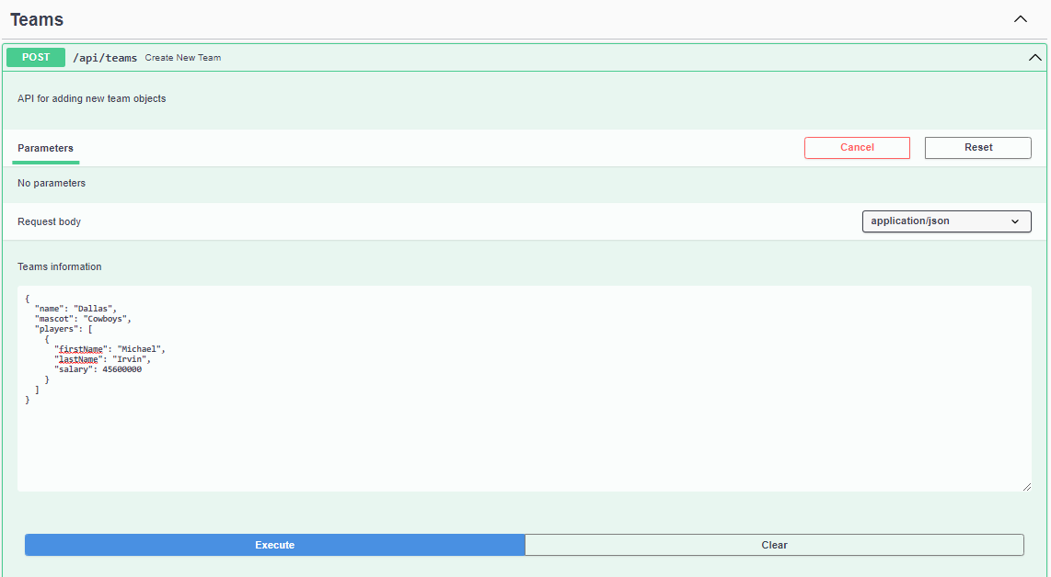

createTeam Post Test in Swagger:

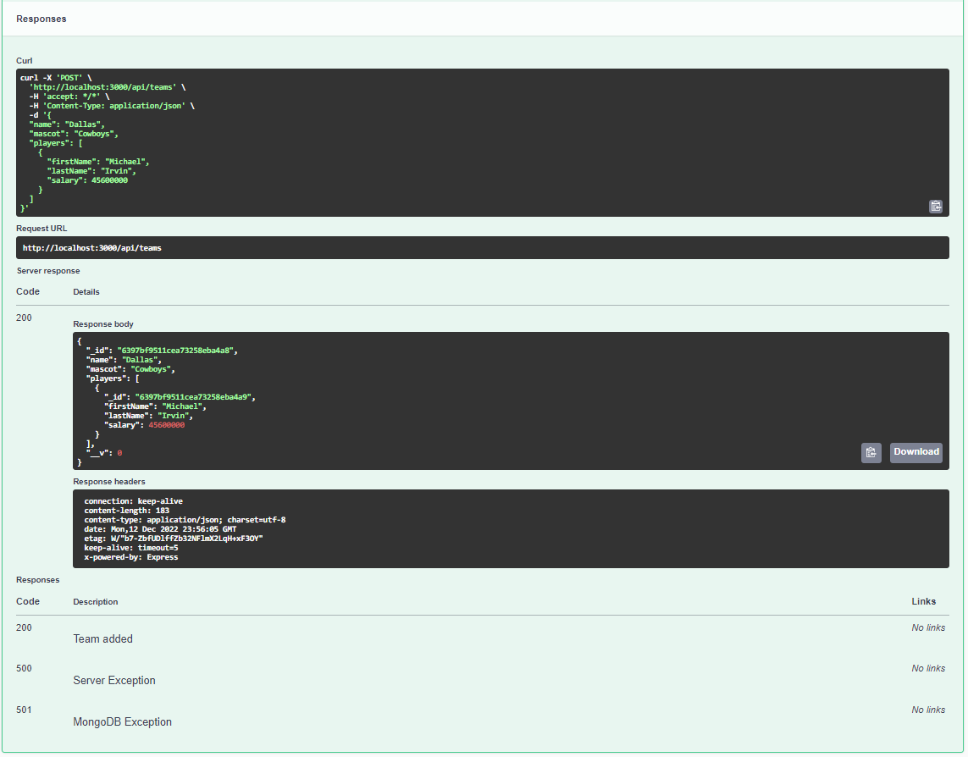

findAllTeams GET test in Soap UI:

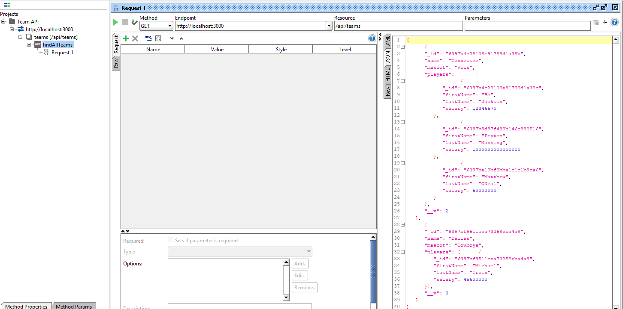

findAllPlayersByTeamId GET Test in Soap UI:

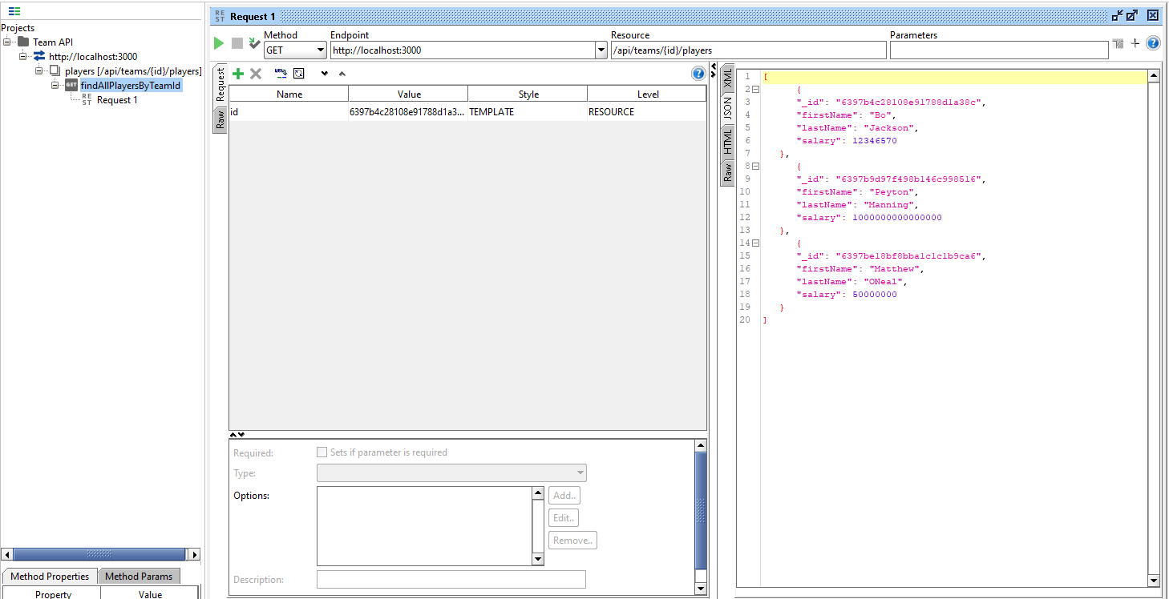

assignPlayerToTeam POST test in Soap UI:

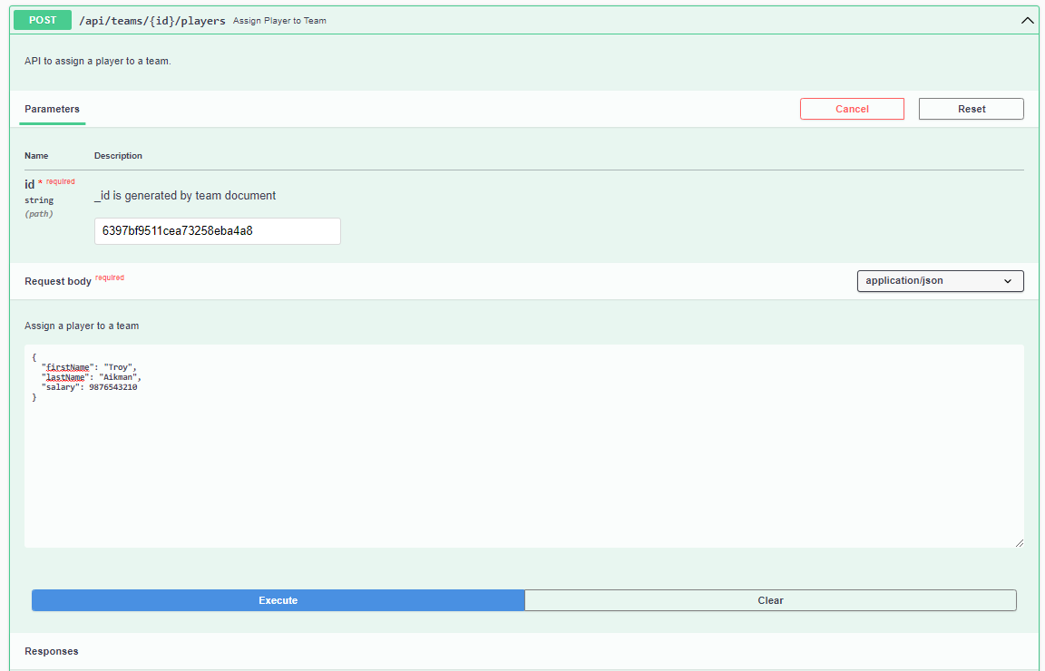

assignPlayerToTeam POST test in Soap UI:

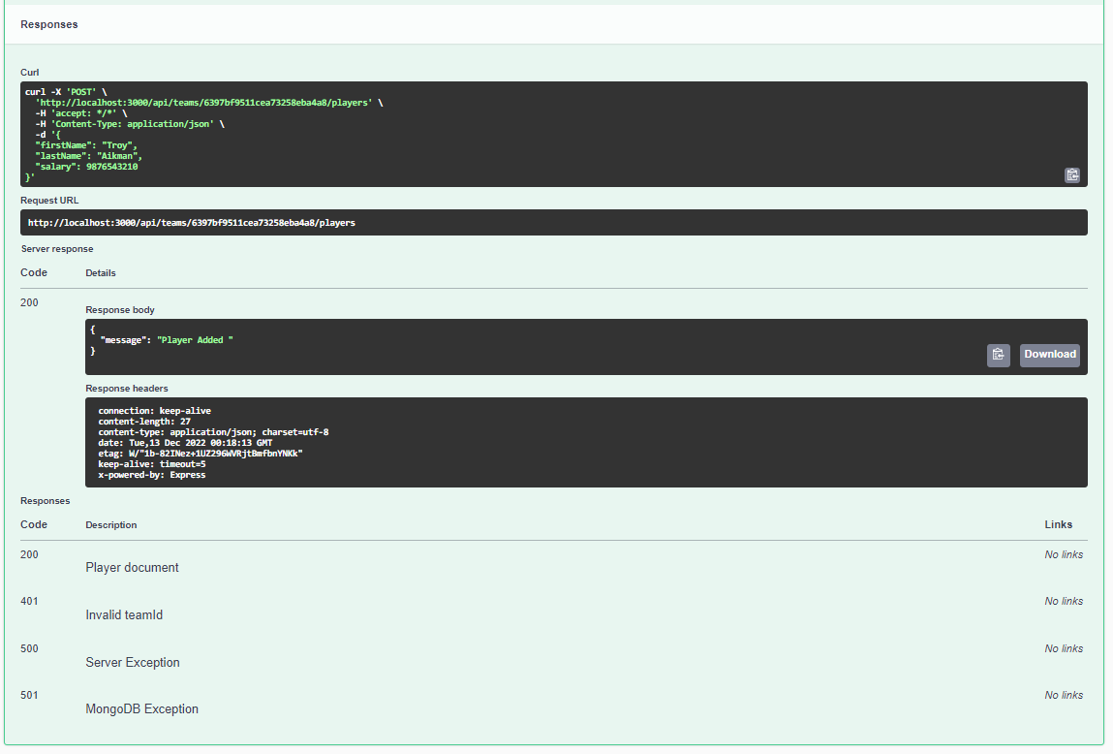

deleteTeamById DEKETE test in Soap Ui:

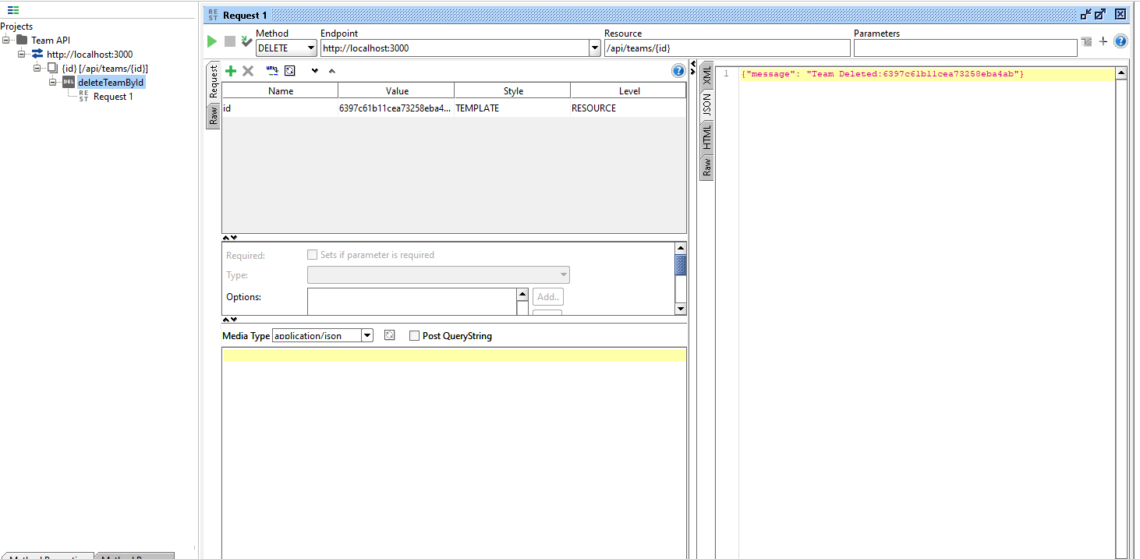

Personal-Portfolio Api Unit Tests Page:

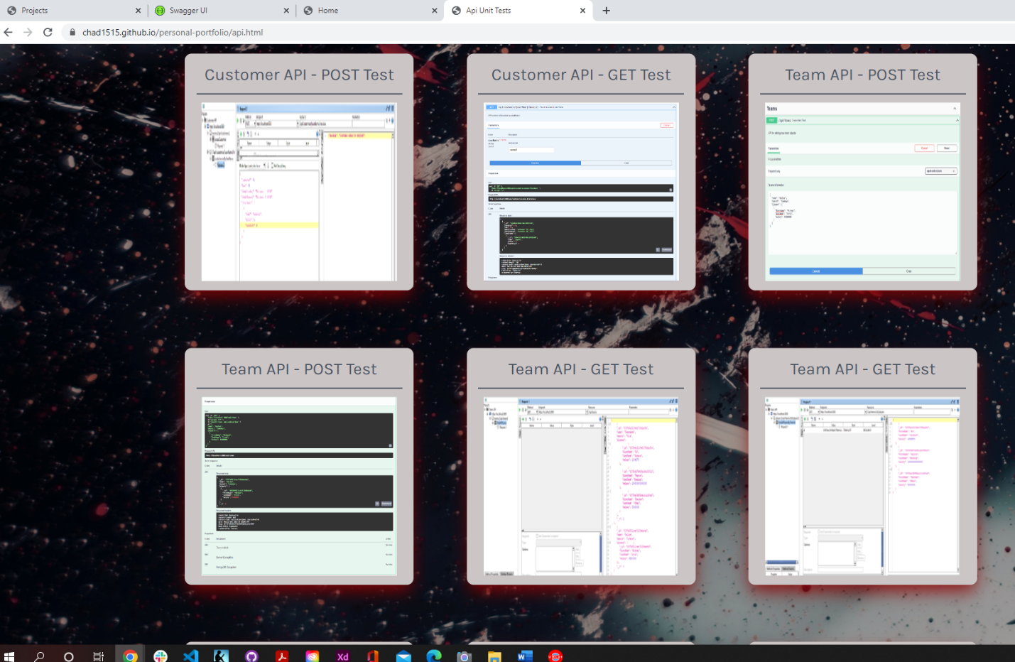

Personal-portfolio Api Unit Tests page:

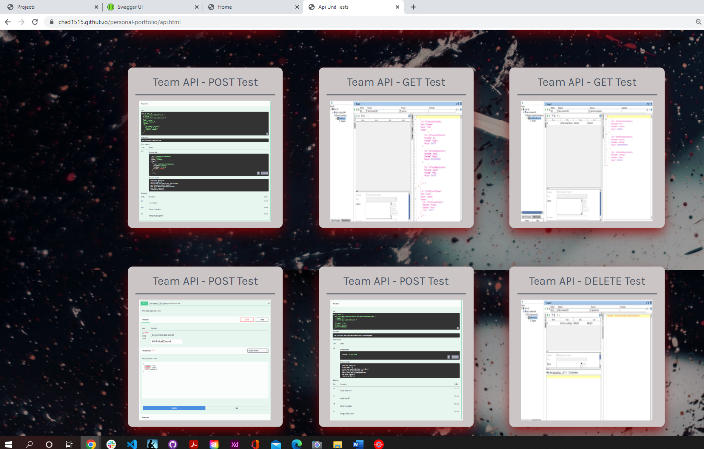

Personal-portfolio Database Diagrams Page:

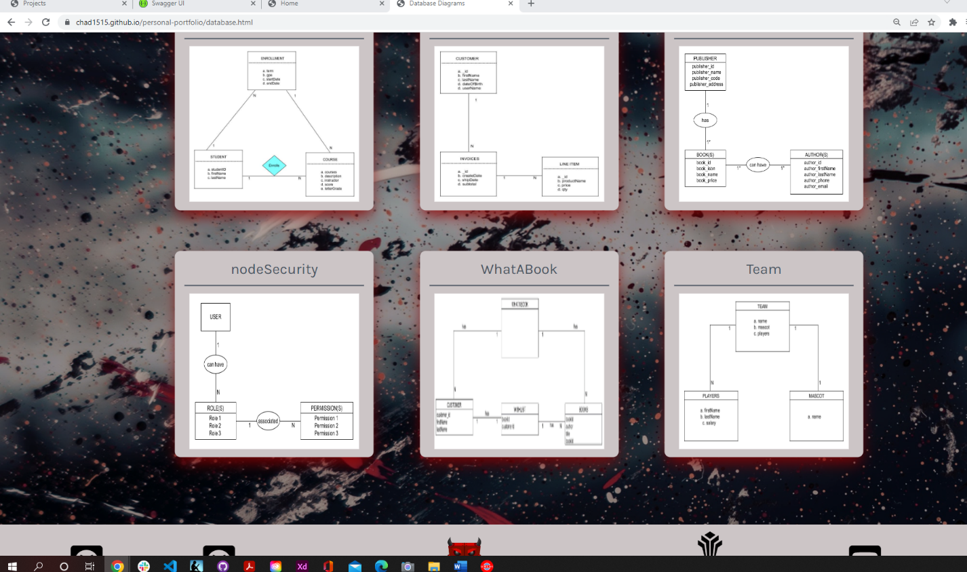

Team ORD: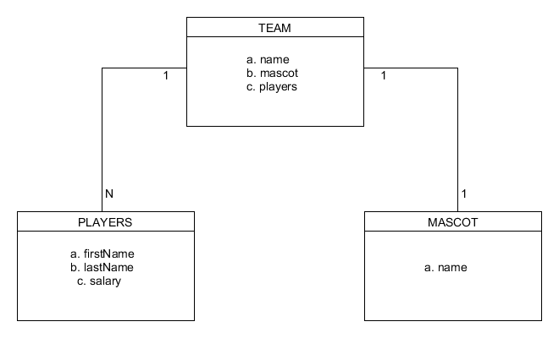

Capstone running on render:

<https://oneal-capstone-api.onrender.com/api-docs/>

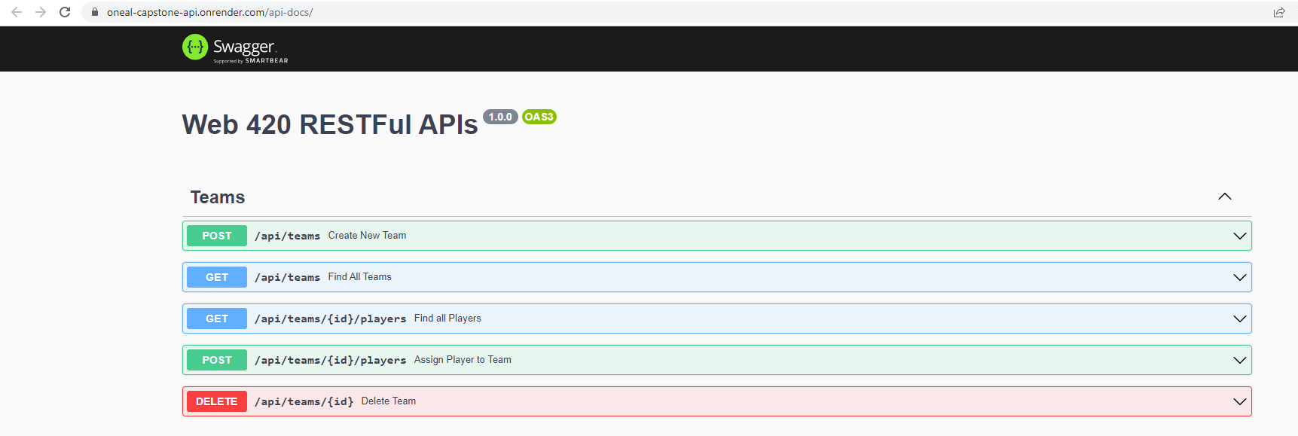

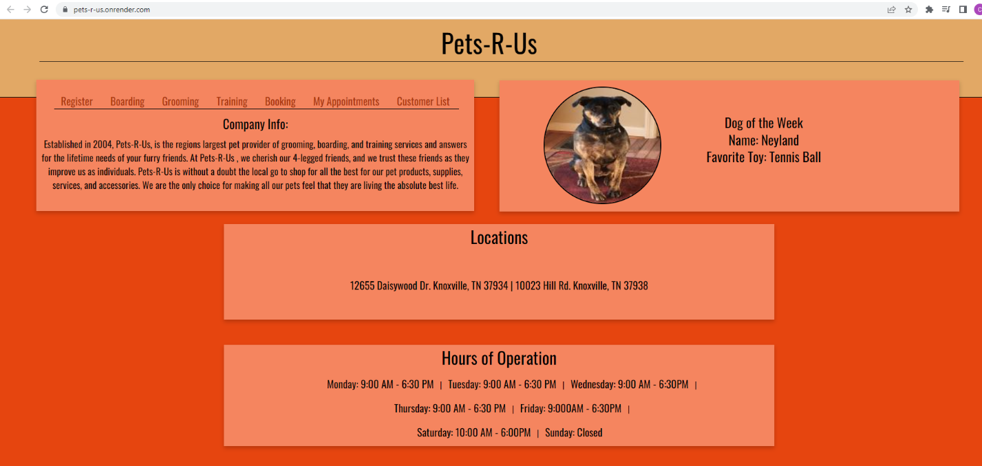Pets-r-us running on render:

<https://pets-r-us.onrender.com/>